|  |  |  |  |  |  |
| --- | --- | --- | --- | --- | --- |
| Date | 6-Dec-22 | | | Tester Name | Mayuri Patel |
| Environment | Penfax - Test | | | Login used |  |
| Operating System | Select OS | Version: | Update: | | |
| Software Used | Select Software | Version: | Update: | | |
| Select Software | Version: | Update: | | |
| Release version | 22.4.1 | | | | |
| Title |  | | | | |
| Test Type | Regression | | | | |
| Test Scenario | Try process a Lump sum under $100 on Pen web | | | | |
|  |  | | | | |
| Expected Results |  | | | | |
| Pass/Fail | Pass | | | JIRA# | N/A |

Describe your steps with screenshots:

Find a VPB active member

Open that member profile

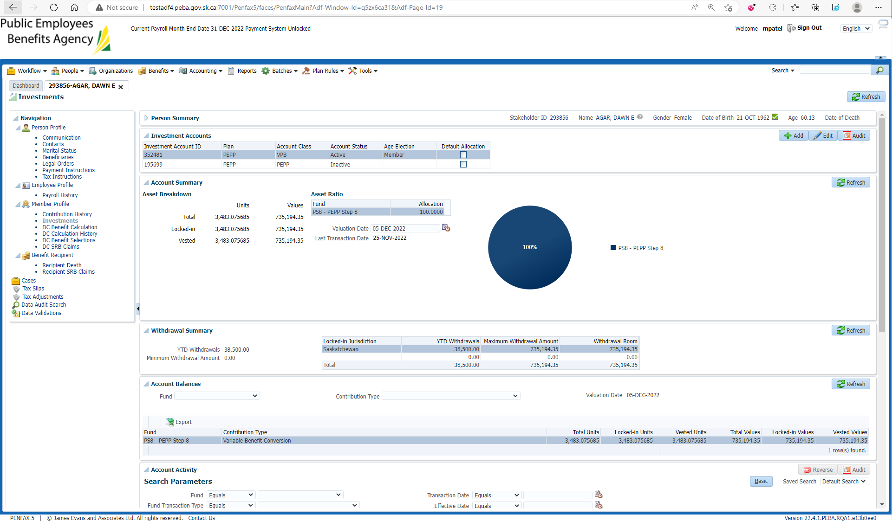

Go to Pen web account of this member

Request Lump sum payment under $100



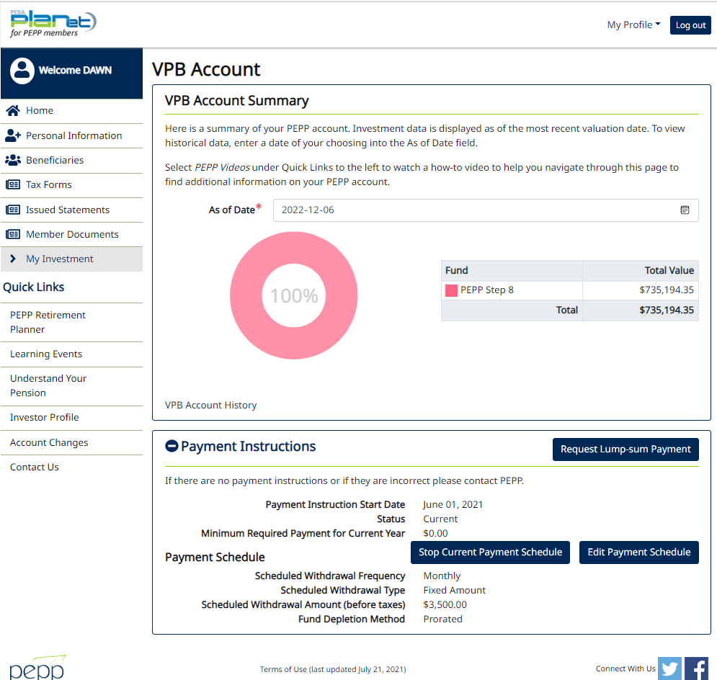

Enter Amount under $100 and next

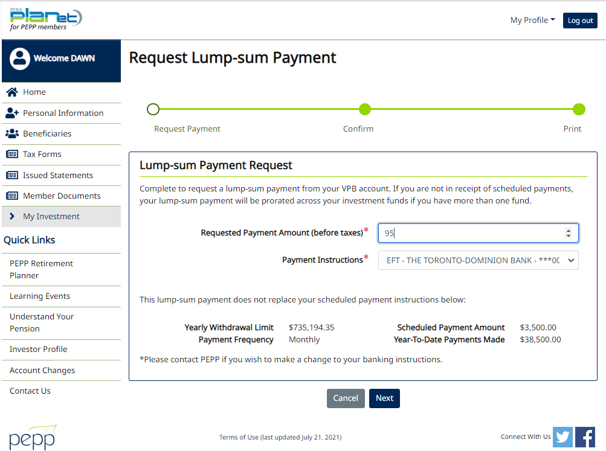

Confirm

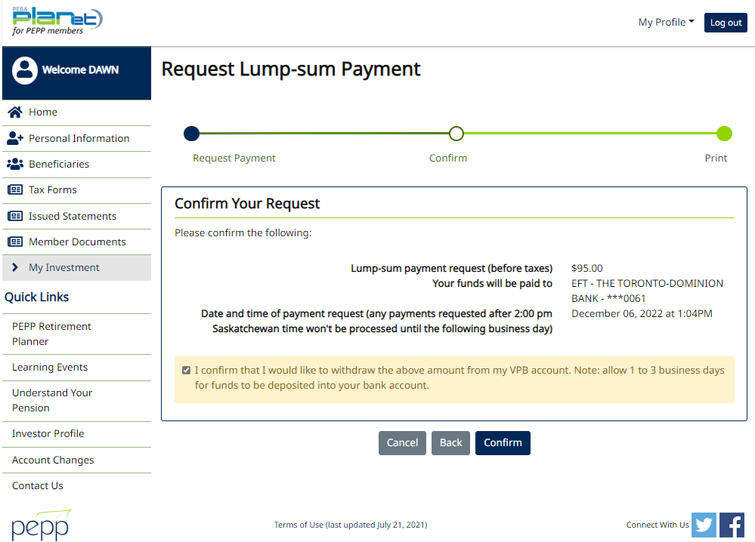

Warning pops up for amount less than $100

